# ACTIVITY 1:

IAM users sign-in link customizable: Instead of the Account ID, the customer name can be updated.

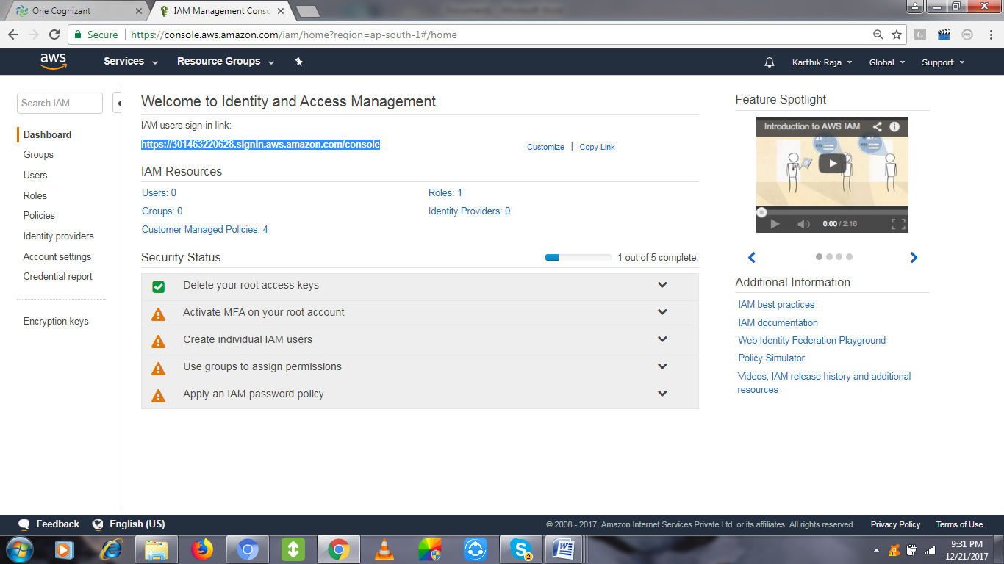

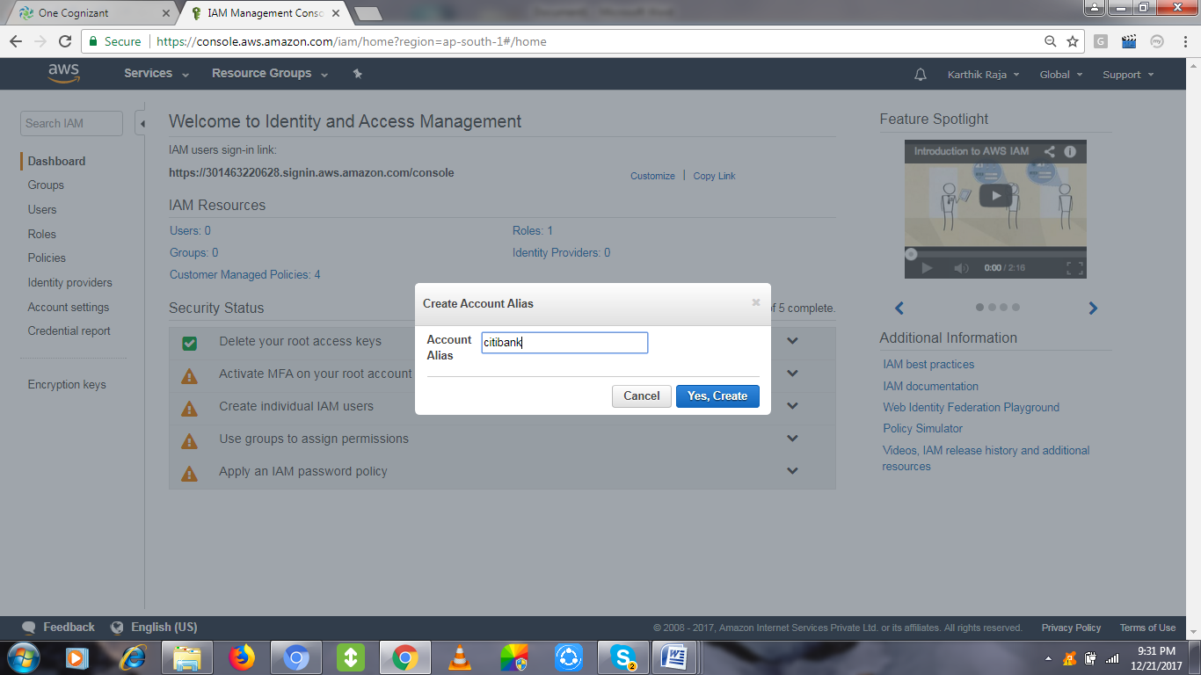

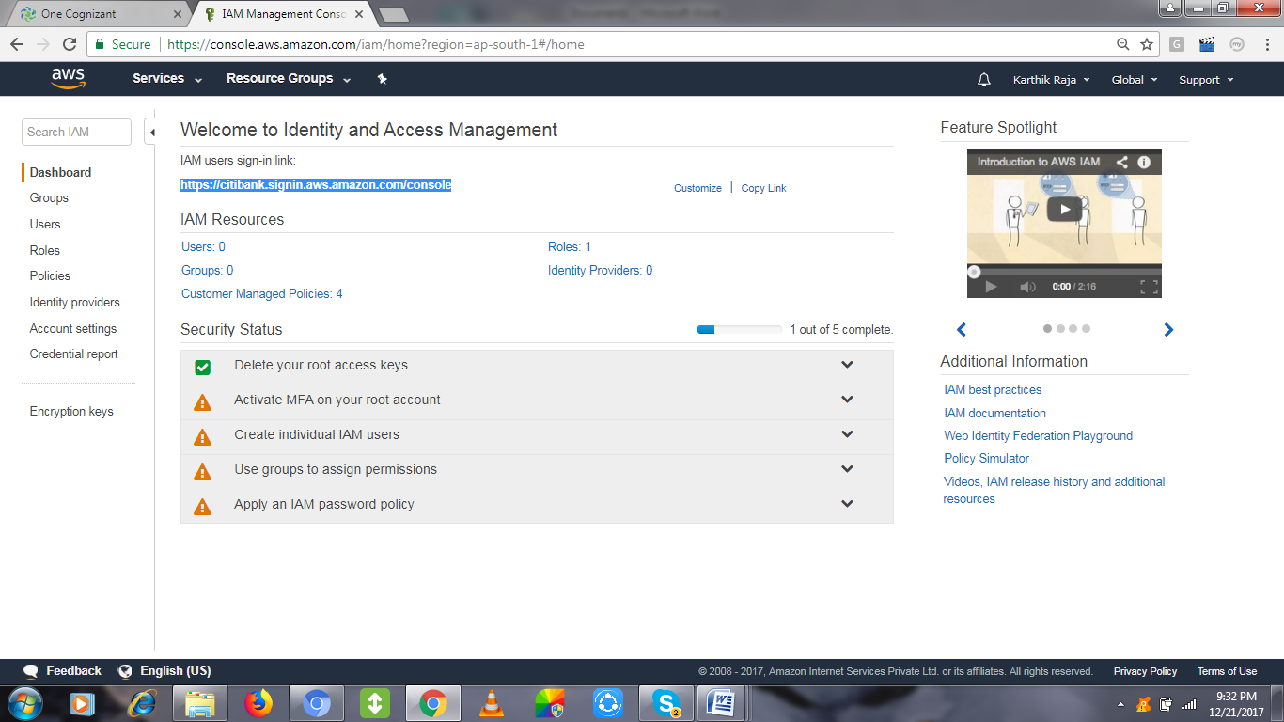

# Activity 2:

Group Creation: Click Create New Group

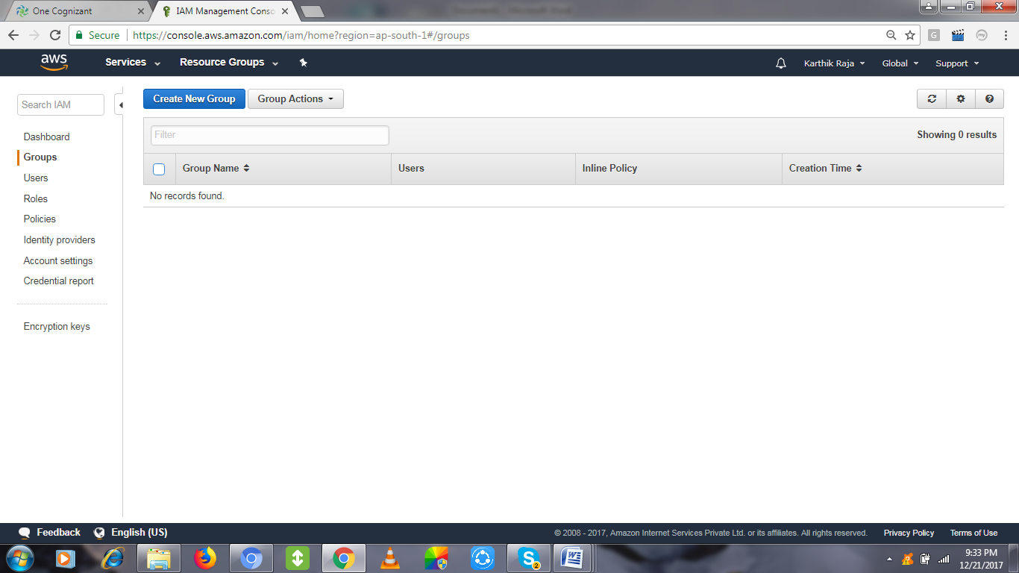

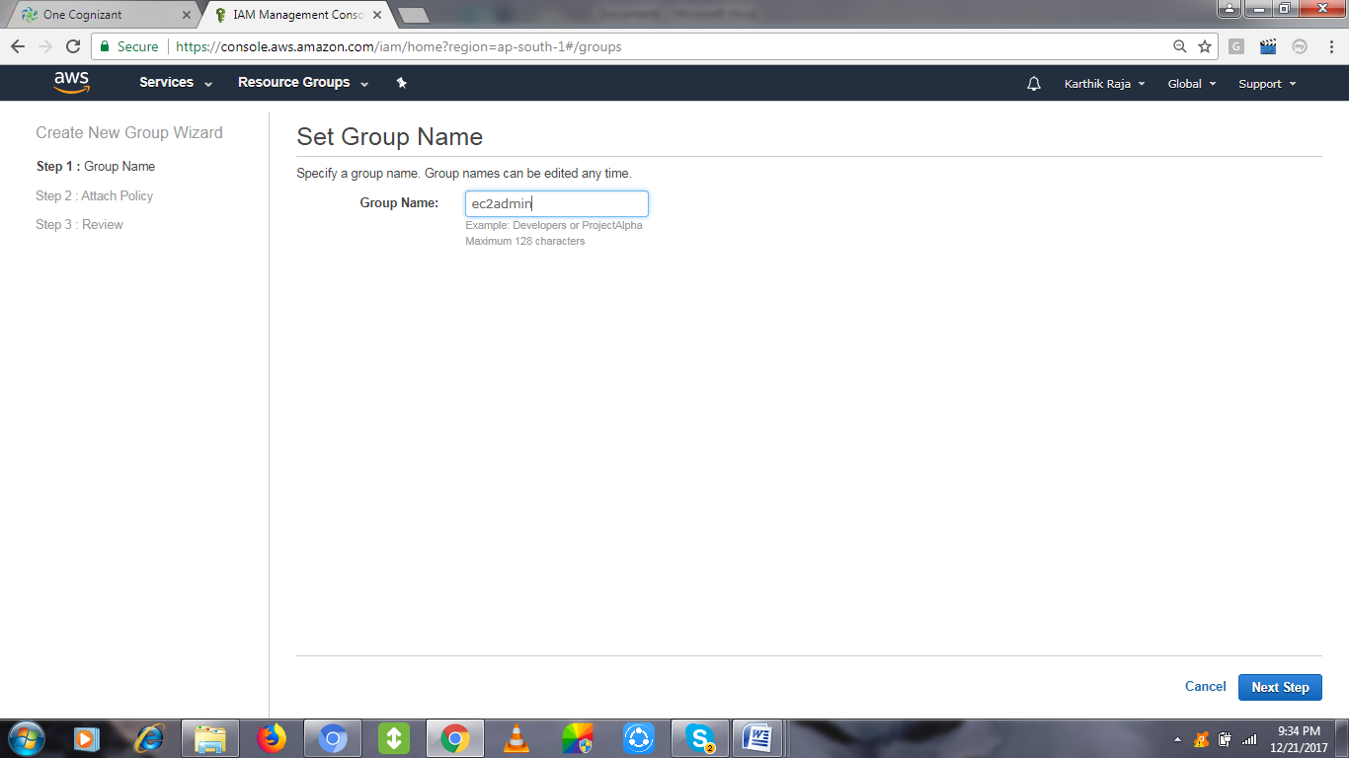

Choose the policy related to the group by using the search tab, like ec2/s3/ any services,

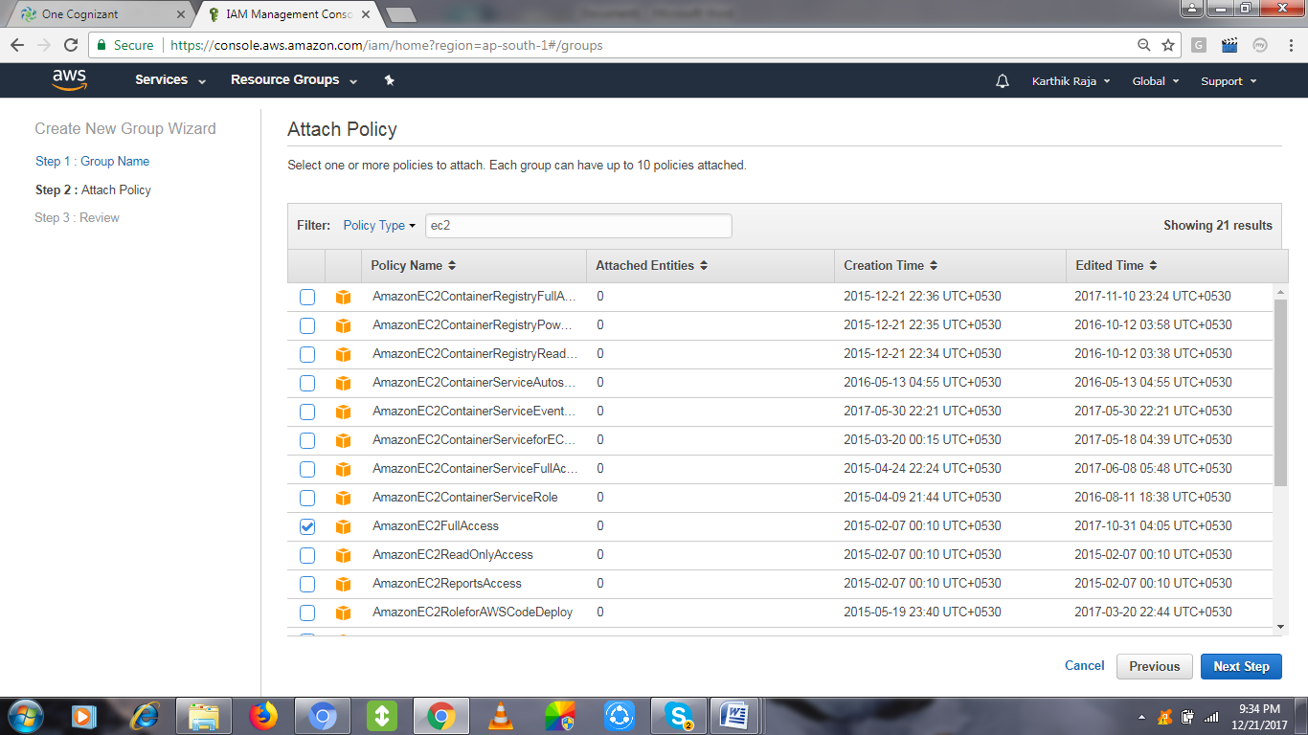

Review the policy & Create Group.

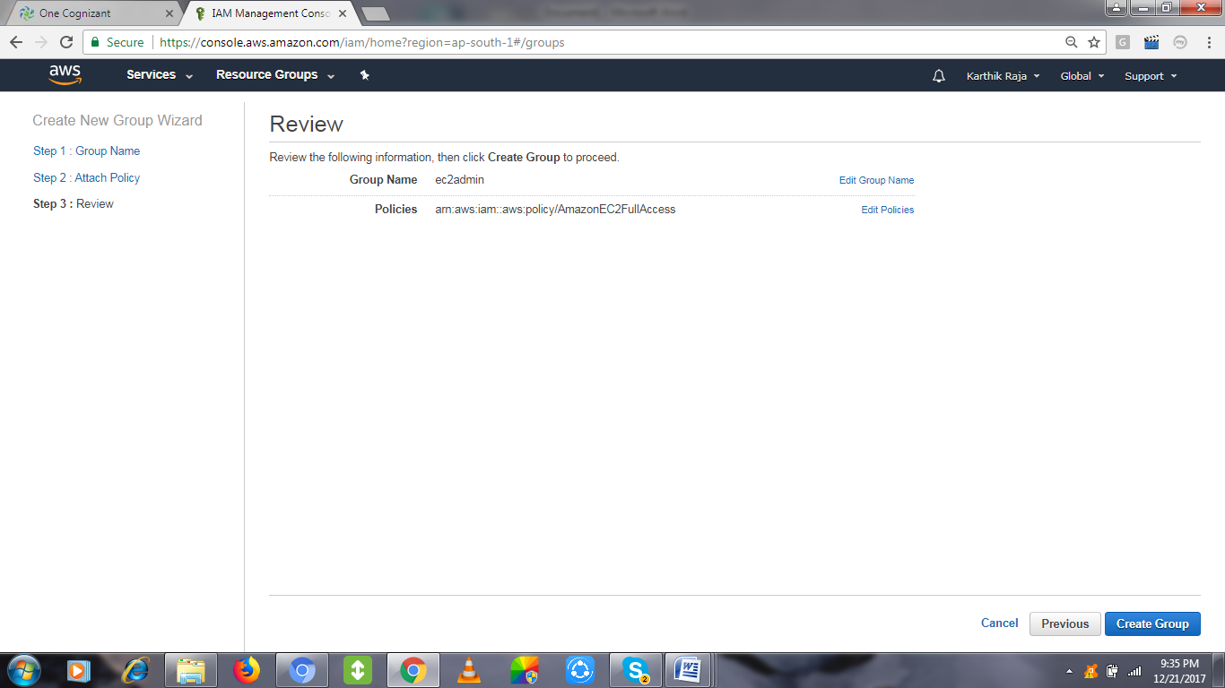

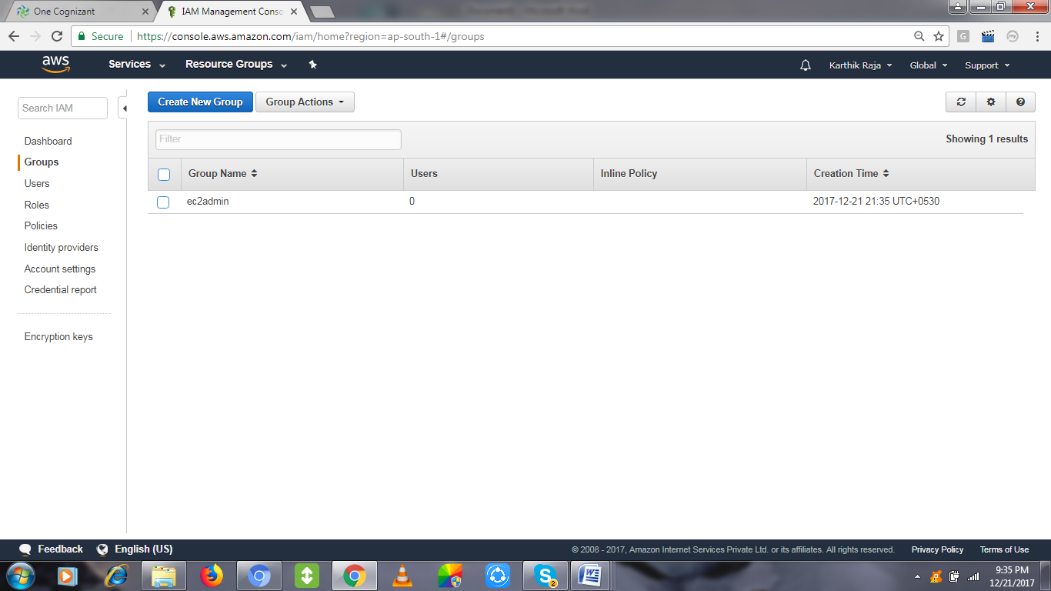

# Activity 3:

User Creation by clicking ADD USER.

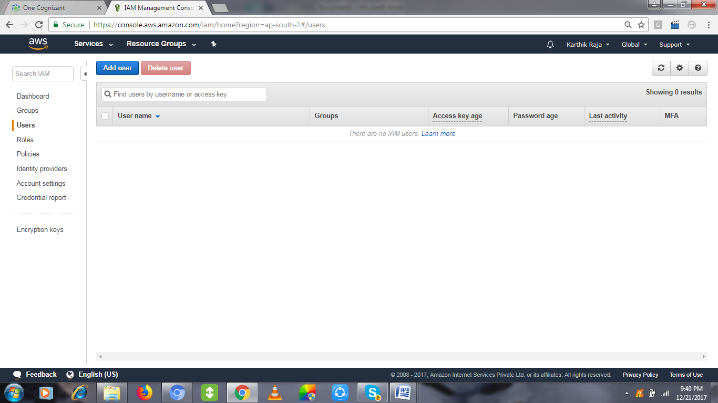

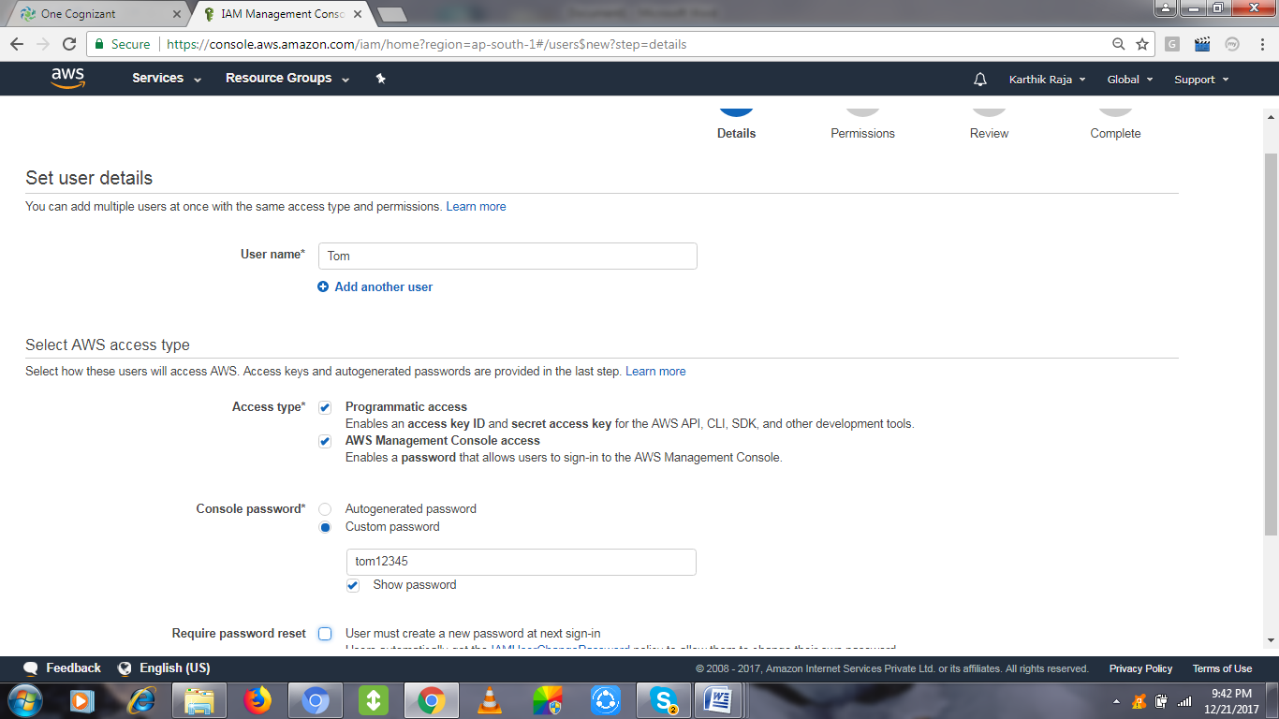

Add the user the existing group o create a group and add.

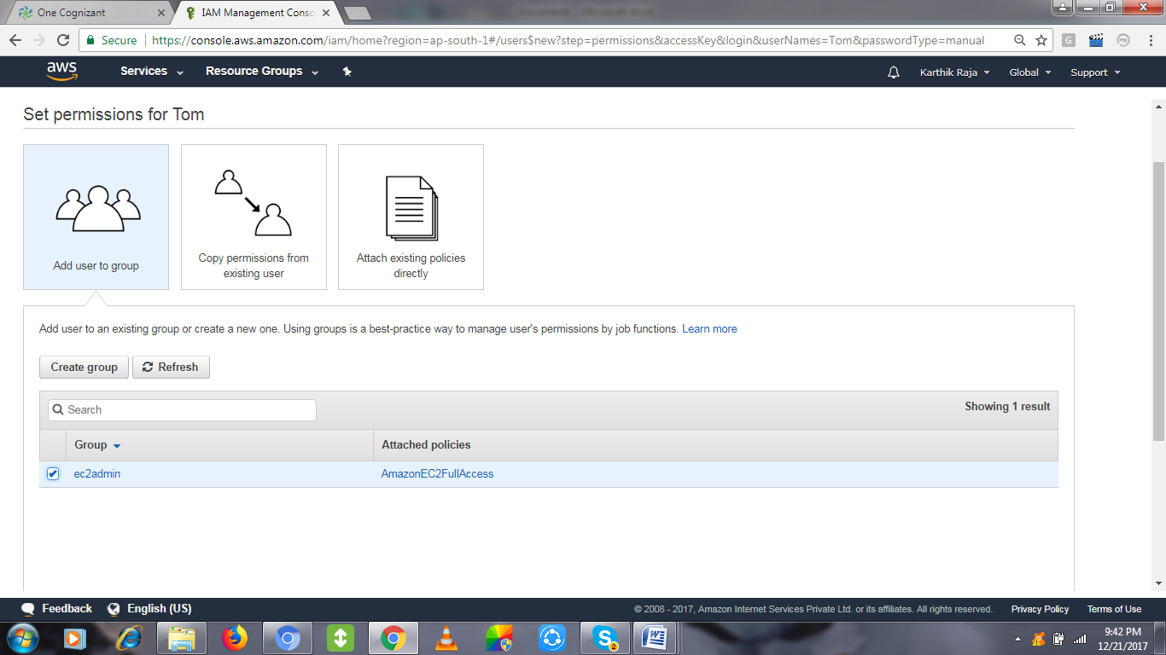

Review and create user finally.

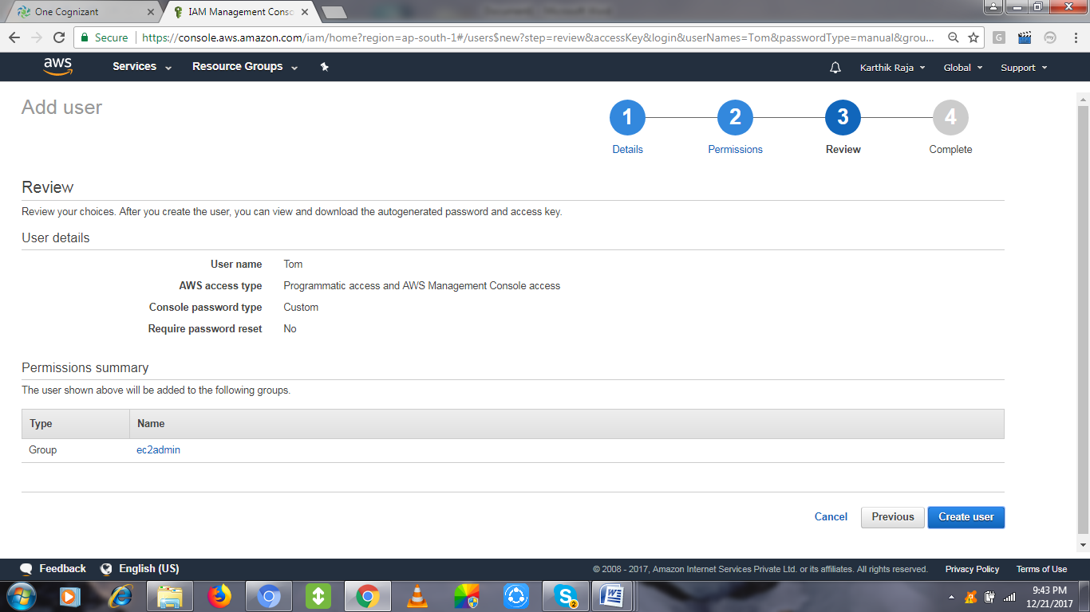

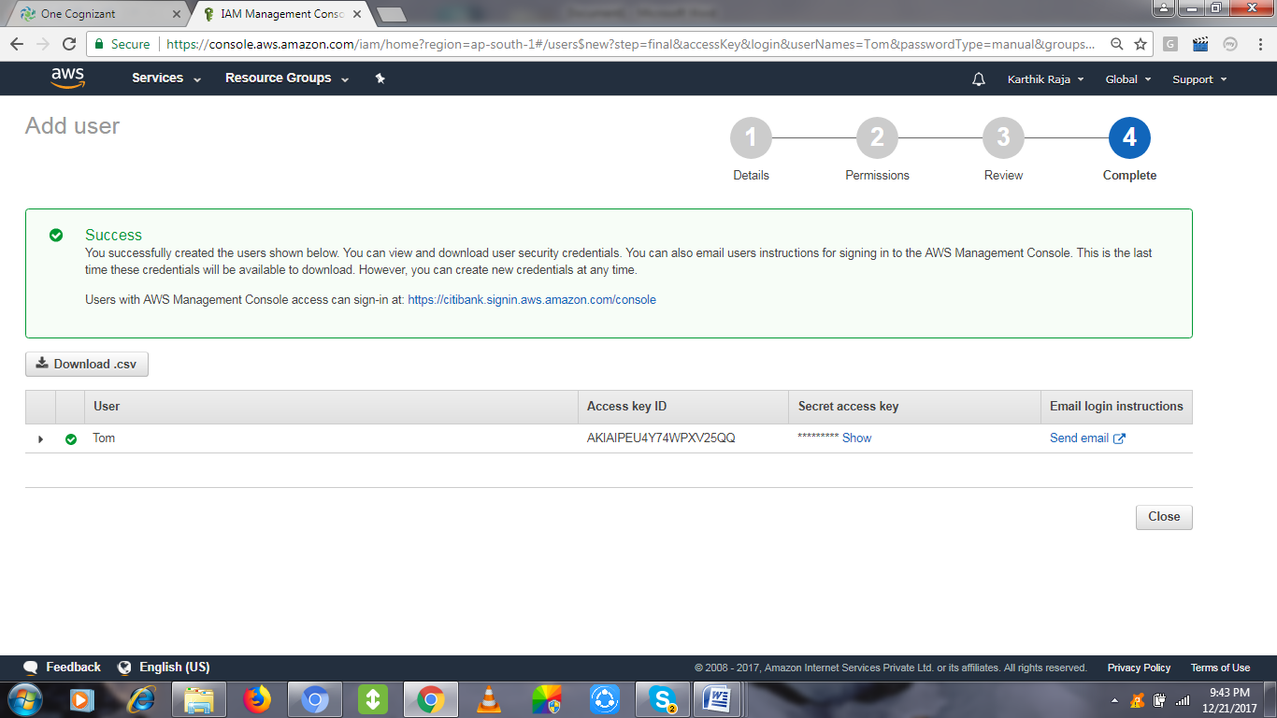

Collect the Access Key ID & Secret access key and keep it safe for rest of the activities.

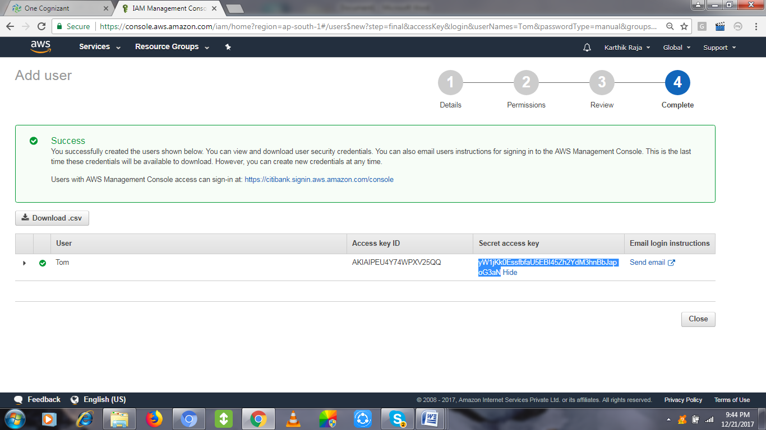

# Activity 4:

Policies are already available set of permission, that to be attached for group/user.

We can create a own Policy too, Click Create Policy

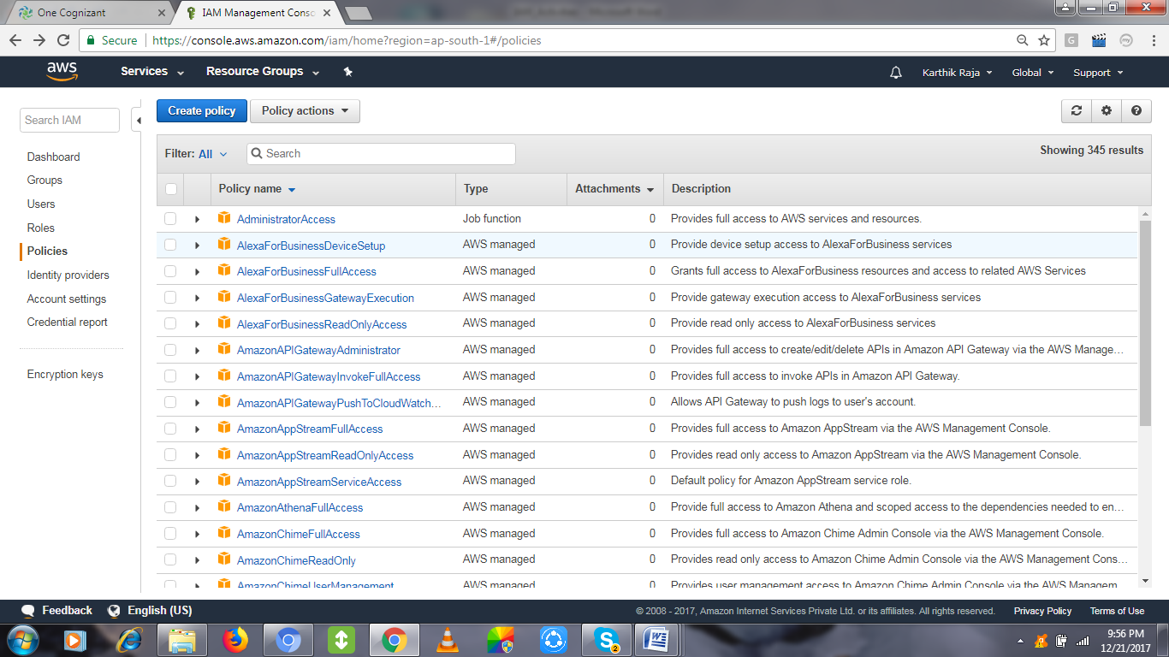

Search the service and pick a portion of access that needs to be provided as permission.

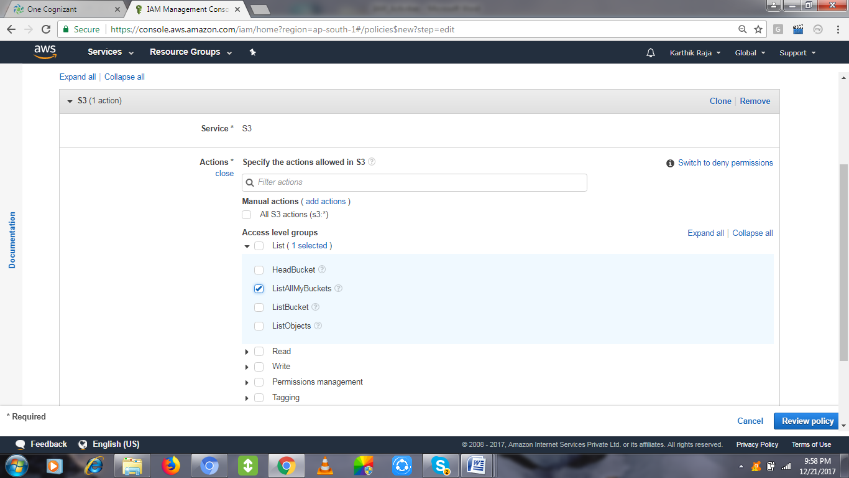

Name the policy, review and create it.

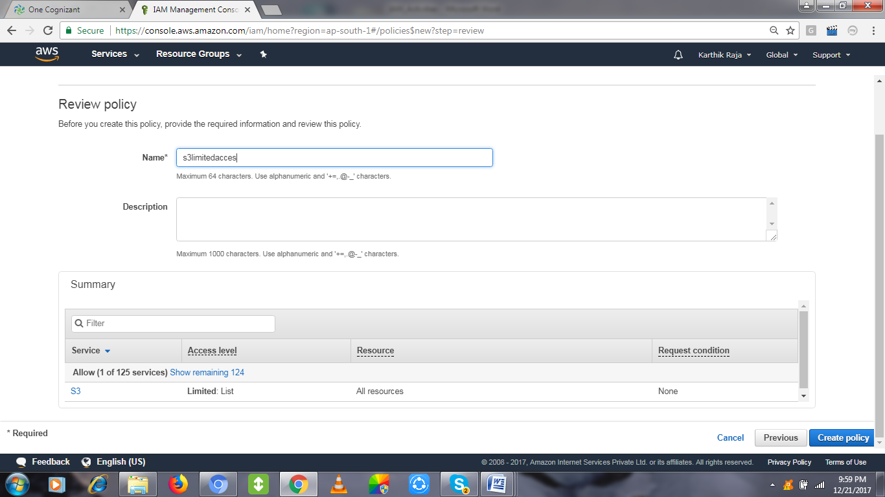

You can check under Customer managed section for the created policy,

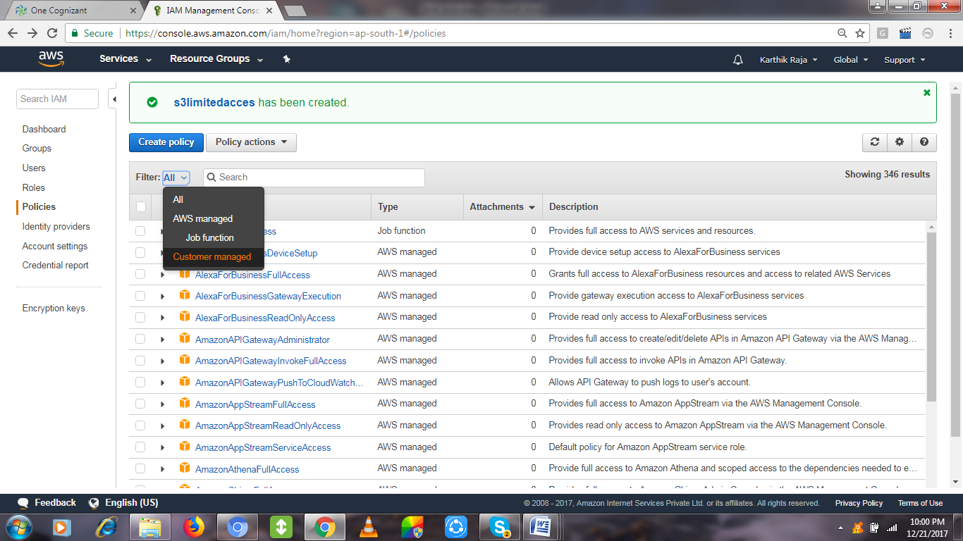

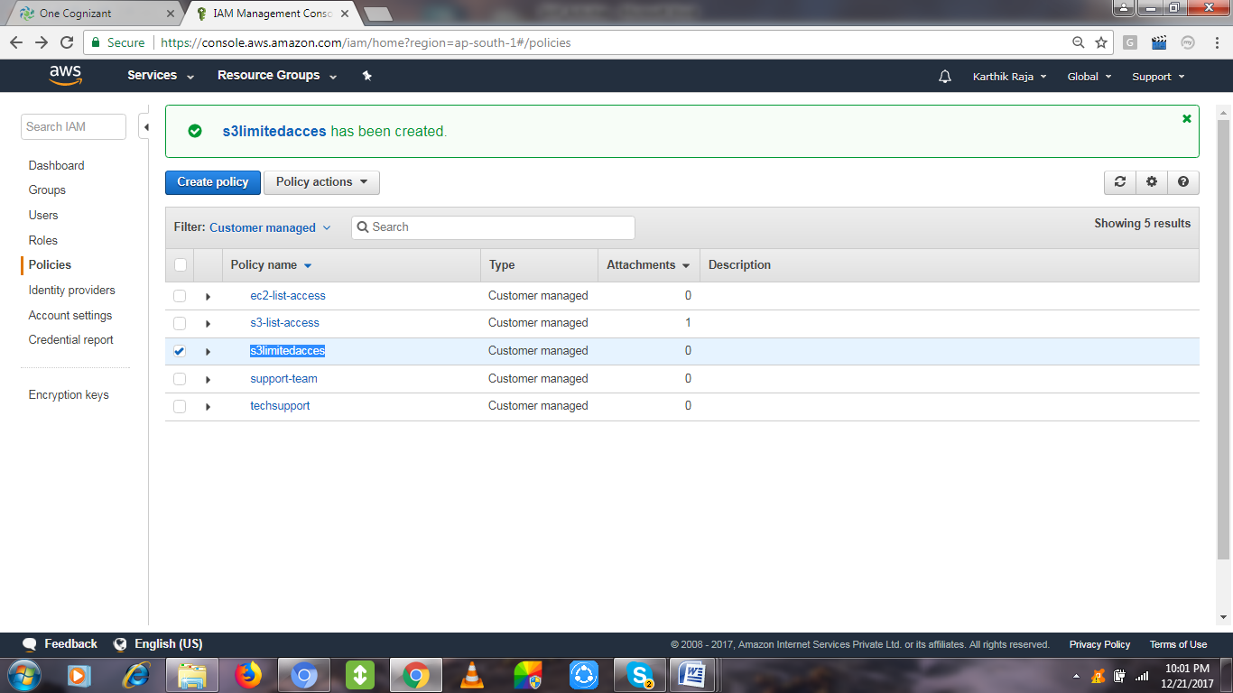

# Activity 5:

Role creation by clicking Create Role

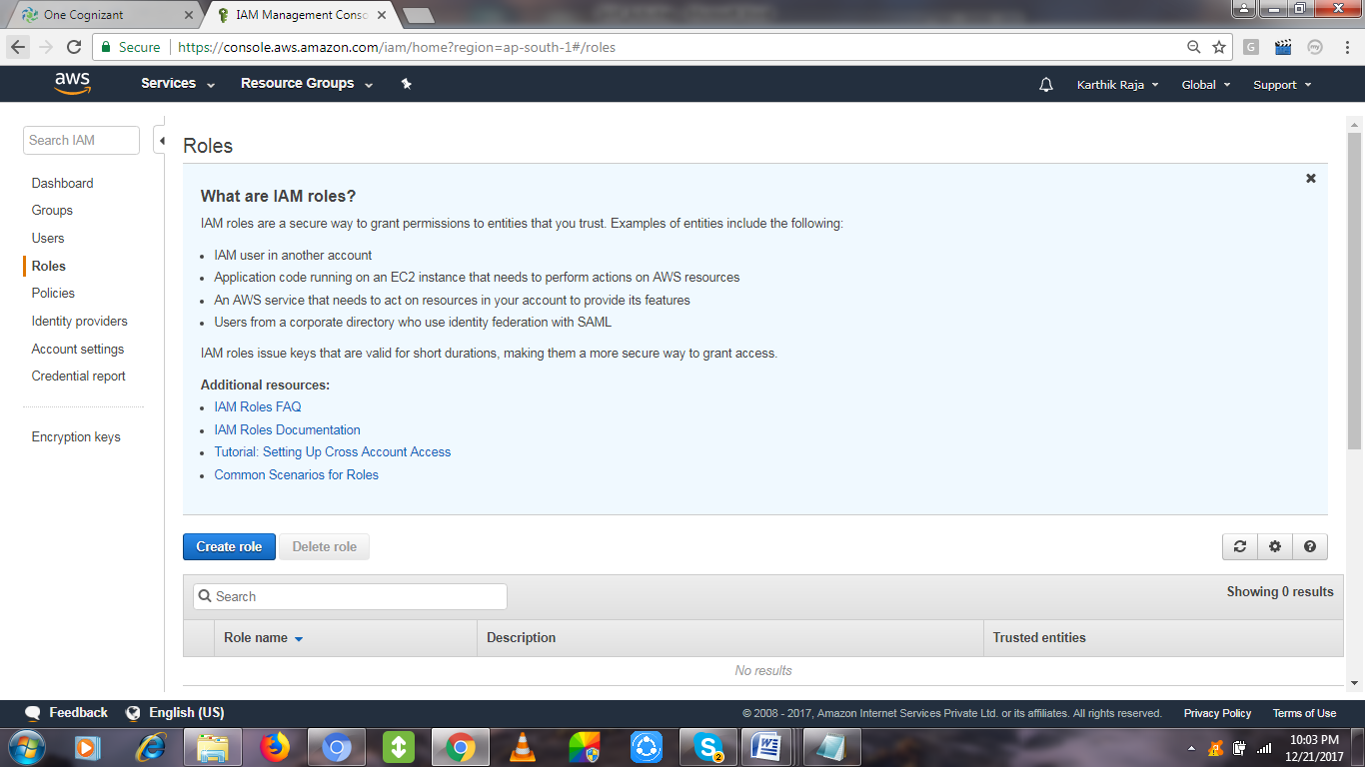

Choose any AWS Resource for allocating Role level mapping for it, Choosing **S3**

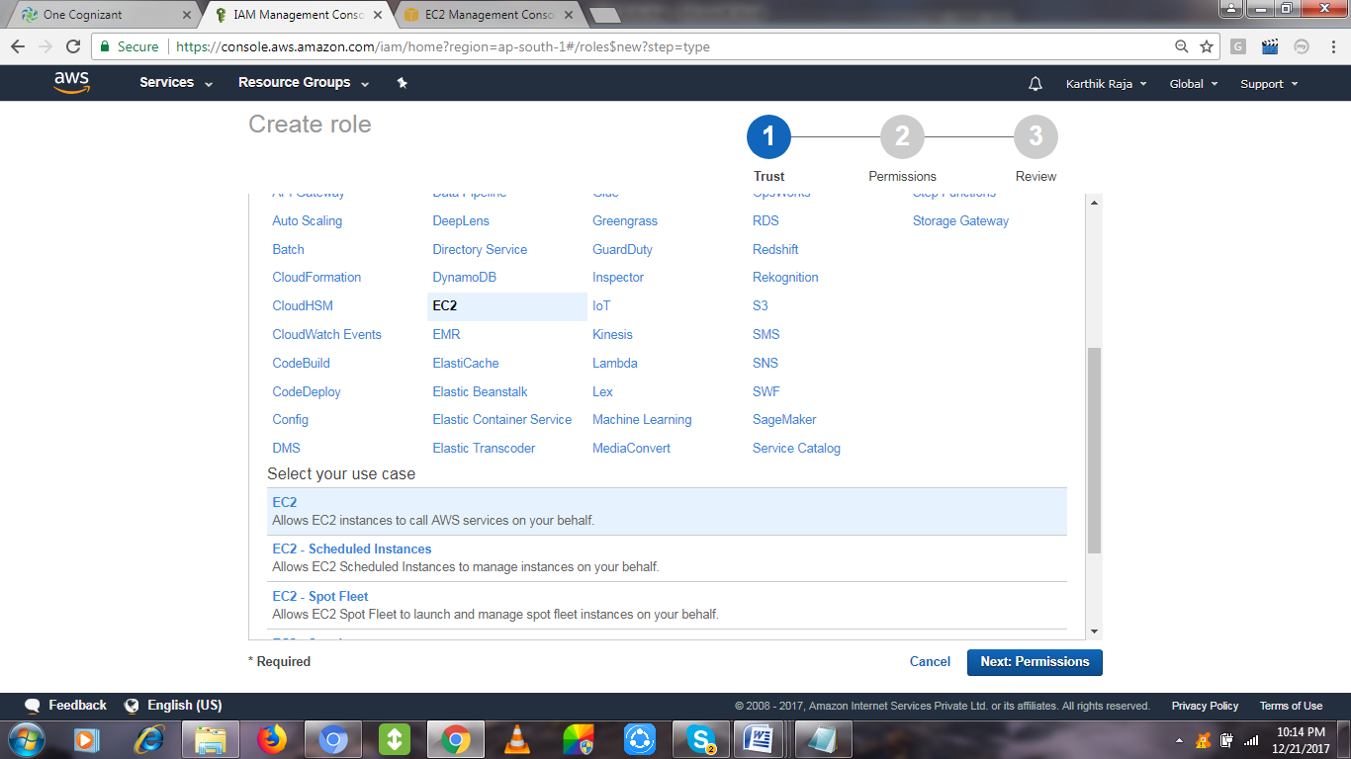

Choosing the customer managed policy, which we created in the earlier activity,

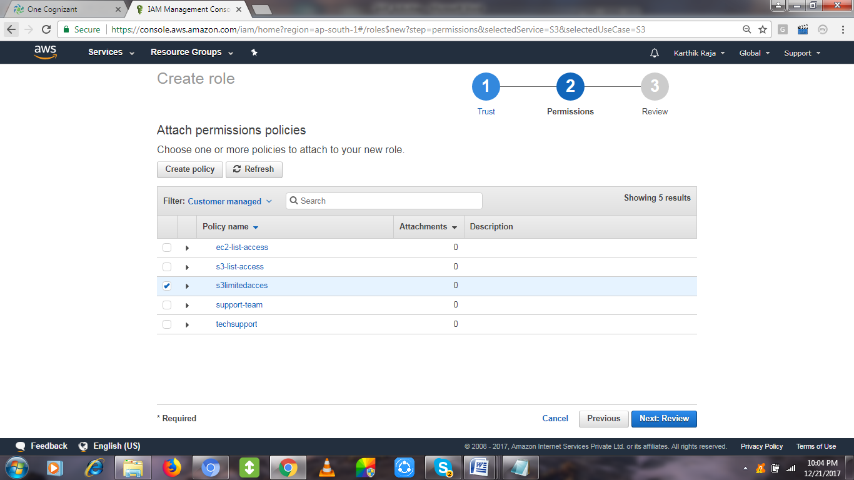

Review and create it with a name for reference to choose this IAM ROLE.

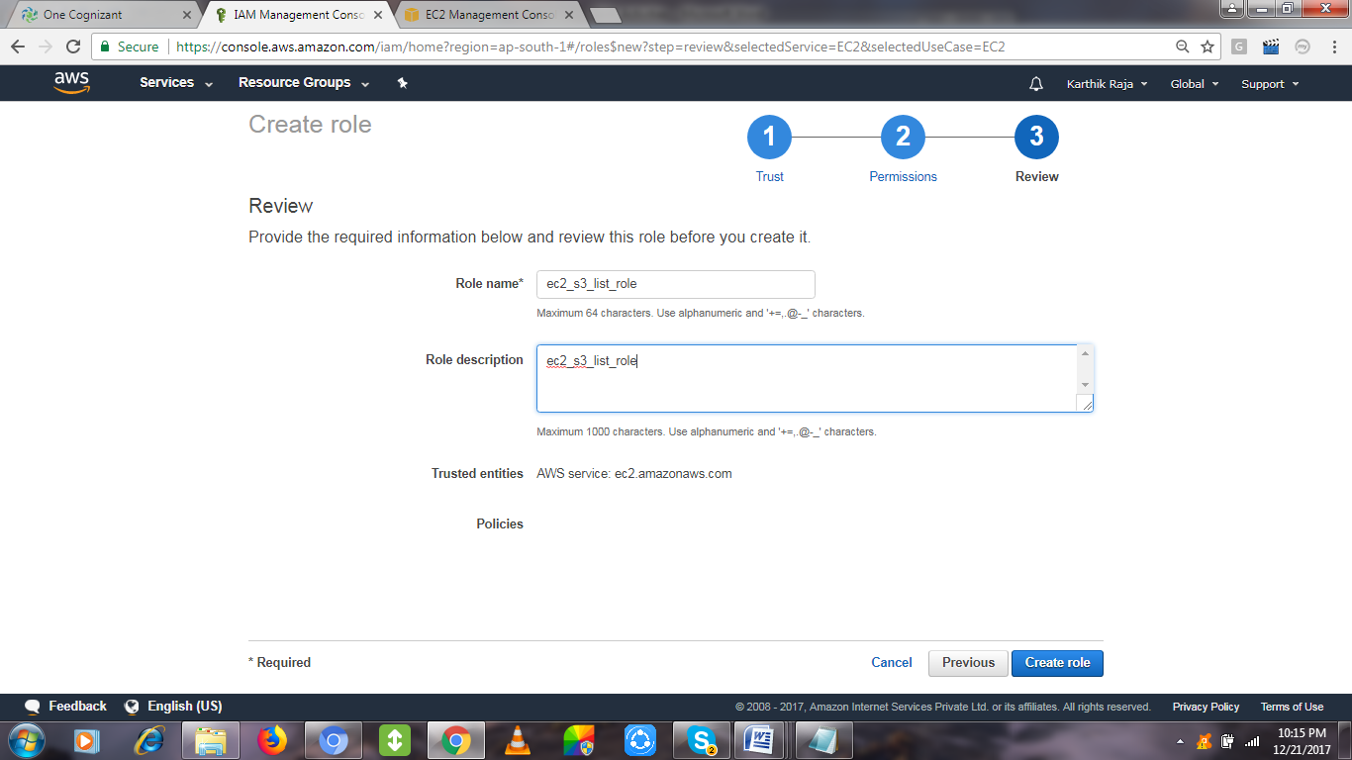

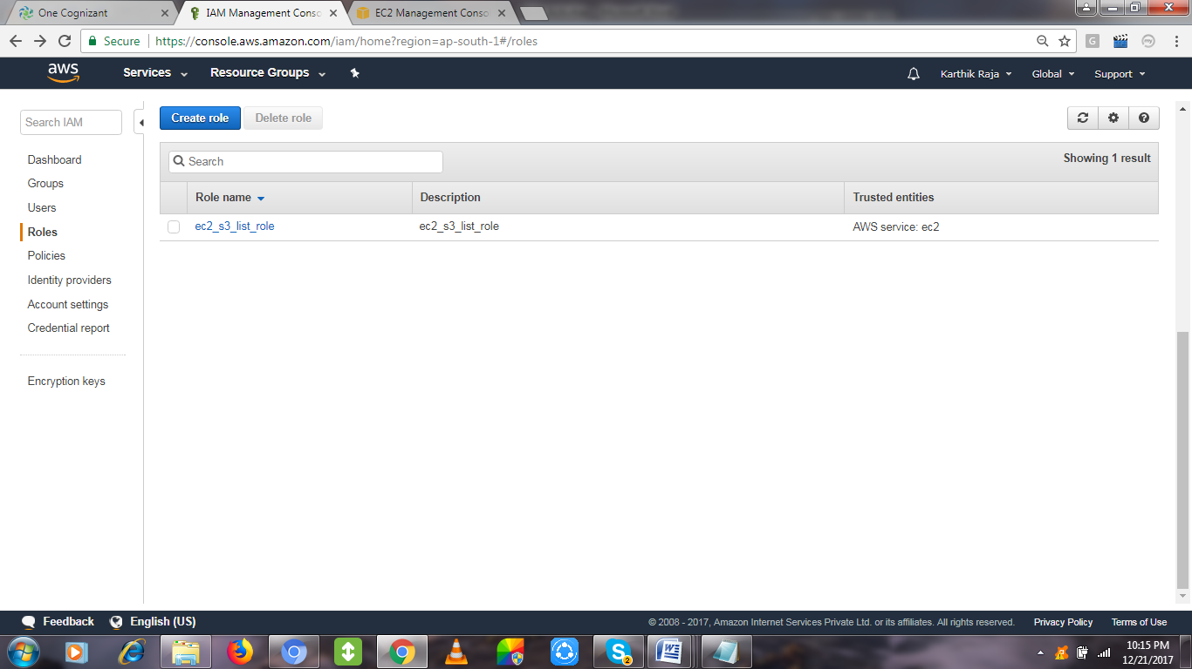

# IAM Role Test scenario:

Create an EC2 with IAM Role attached to it, so that after login in into the EC2 server it will not expect

* “aws configuration” to list the S3 listing activity [for which the role has been created].
* Also No access/secret key is required for setting the configuration.

**Mapping the created the Role for the Creating EC2:**

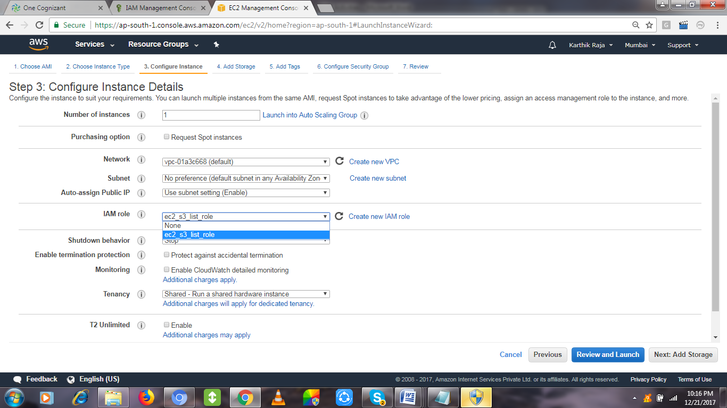

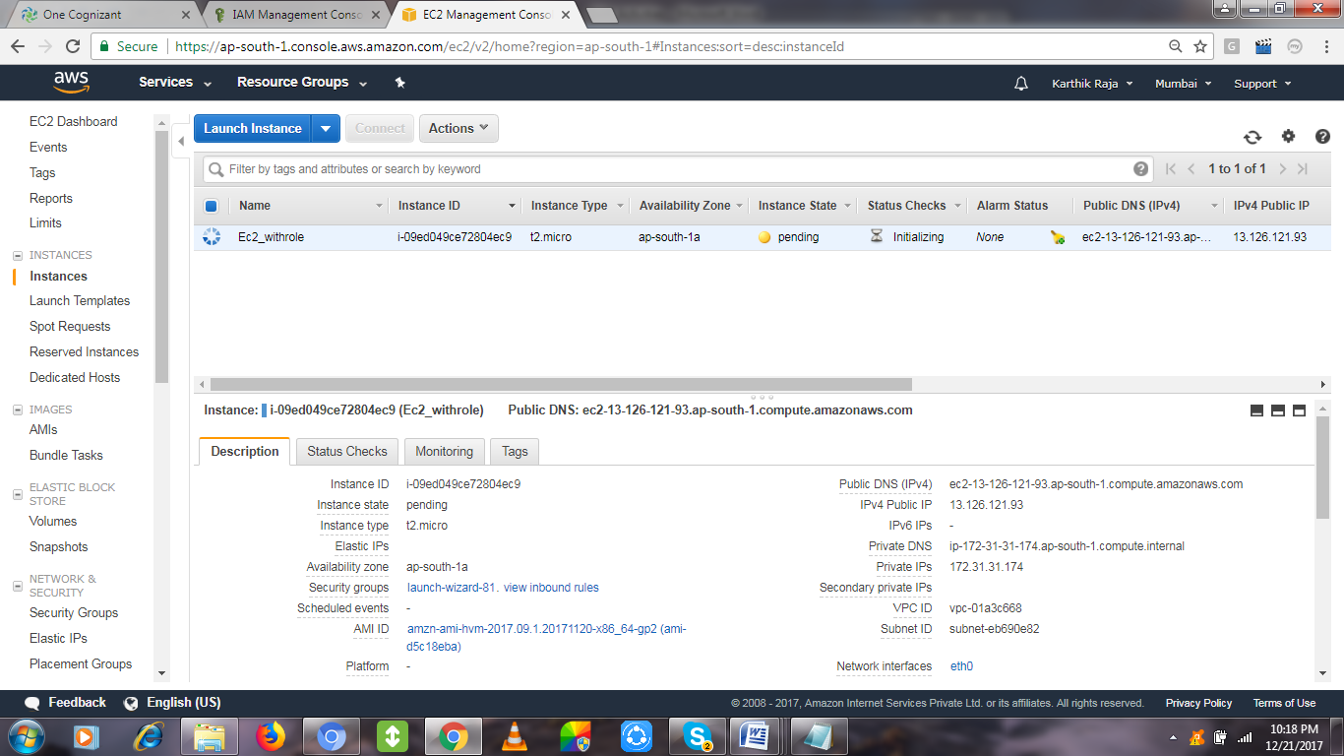

Once login into the EC2 and check with the S3 Bucket Listing command – **aws s3 ls**

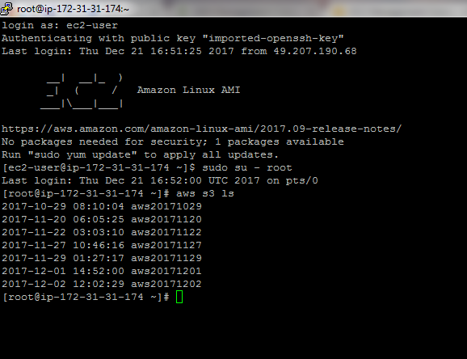

Compare the same by creating an EC2 without attaching the role, you can see the difference.

It will ask Access/Secret Key, etc,.

